St Andrew’s Church
Warrington

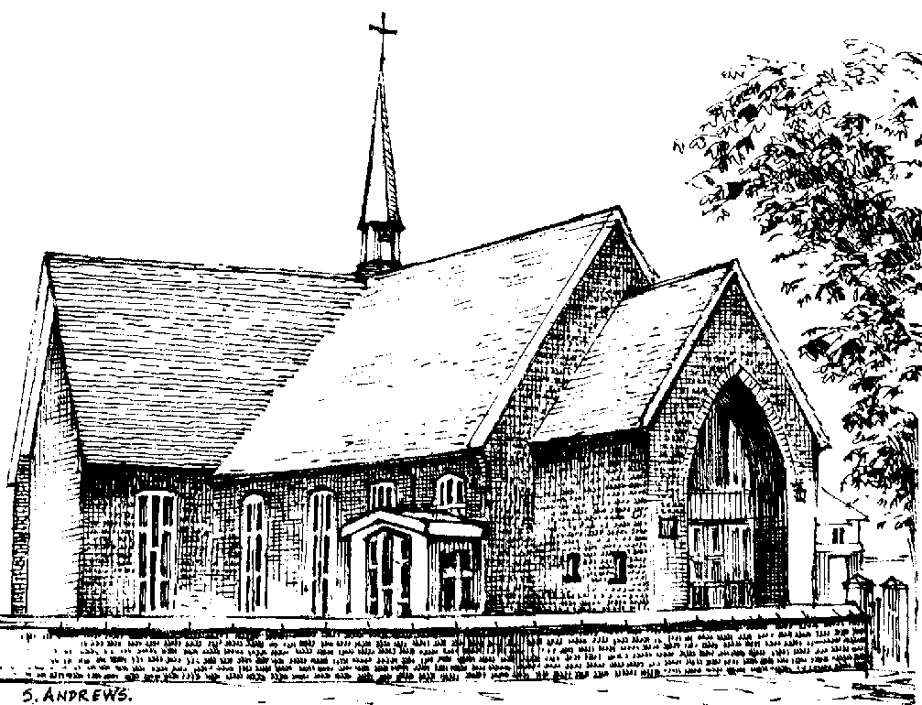

Joan Sutton

14.6.1938 – 21.10.2011

Wednesday 2nd November 2011

Order of Service

Please stand as the procession enters church to “If tomorrow never comes” sung by Ronan Keating

Opening prayers:

All: Merciful Father, hear our prayers and comfort us; renew our trust in your Son, whom you raised from the dead; strengthen our faith that all who have died in the love of Christ will share in his resurrection; who lives and reigns with you, in the unity of the Holy Spirit, one God, now and for ever. Amen

Hymn: The Lord's my Shepherd, I'll not want;
he makes me down to lie -
in pastures green; he leadeth me -
the quiet waters by.

My soul he doth restore again,
and me to walk doth make -
within the paths of righteousness,
e'en for his own name's sake.

Yea, though I walk through death's dark vale,
yet will I fear no ill;
for thou art with me, and thy rod -
and staff me comfort still.

My table thou hast furnished
in presence of my foes;
my head thou dost with oil anoint ,
and my cup overflows.

Goodness and mercy all my life
shall surely follow me;
and in God's house, for evermore
my dwelling place shall be.
Scriptural reading: John 14. 1-6

The Address and Family Tributes written by Barry and Tina, sisters Maureen
and Gladys, and Jack on behalf of the family

Hymn: On a hill far away stood an old rugged cross,
The emblem of suff'ring and shame;
and I love that old cross where the dearest and best
For a world of lost sinners was slain.
So I'll cherish the old rugged cross
Till my trophies at last I lay down;
I will cling to the old rugged cross
And exchange it some day for a crown.

To the old rugged cross I will ever be true,
Its shame and reproach gladly bear;
Then He'll call me some day to my home far away,
Where his glory for ever I'll share.
So I'll cherish the old rugged cross

The Prayers

Hymn: Fight the good fight with all thy might;
Christ is thy strength and Christ thy right;
lay hold on life, and it shall be
thy joy and crown eternally.

Run the straight race through God’s good grace,
lift up thine eyes, and seek his face;
life with its way before us lies;
Christ is the path, and Christ the prize.

Cast care aside, lean on thy guide;
his boundless mercy will provide;
trust, and thy trusting soul shall prove
Christ is its life, and Christ its love.
Faint not nor fear, his arms are near;
he changeth not, and thou art dear;
only believe, and thou shalt see
that Christ is all in all to thee.

Prayer at the commendation (please remain standing):

All: Heavenly Father, in your Son Jesus Christ you have given us a true faith and a sure hope. Strengthen this faith and hope in us all our days, that we may live as those who believe in the communion of saints, the forgiveness of sins and the resurrection to eternal life; through Jesus Christ our Lord. Amen.

At the end of the service, “Time to say goodbye” sung by Sarah Brightman

